Bus pass with barcode reader

# Part A: Software Development Methodology

Agile Methodology is a type of project management process. The agile method anticipates change and allows for much more flexibility than traditional methods. Clients can make small objective changes without huge amendments to the budget or schedule. The process involves breaking down each project into prioritized requirements, and delivering each individually within an iterative cycle. An iteration is the routine of developing small sections of a project at a time. Each iteration is reviewed and assessed by the development team and client. The insights gained from the assessment are used to determine the next step in development. Clients come to prescheduled regular meetings to review the work completed the previous iteration, and to plan work for the upcoming iteration. Detailed goals are set in each iteration meeting such as; expected changes, time estimates, priorities and budgets.

The agile method is based on giving high priority to customer participation, from the very beginning of the development cycle. The objective is to keep the client involved at every step so that they have a product that they are happy with at the end. This method saves the client money and time because the client tests and approves the product at each step of development. If there are defects or challenges, then changes can be made during production cycles to fix the issue. Traditional models of project management would not find defects as early because they do not test as often. Typically (in traditional methods of production) defects that are not discovered at the different stages can find their way into the final product. This can result in increased overhead prices and client dissatisfaction.

Businesses have proven this model of project management with their increased client satisfaction rate. The value for businesses that use this model include:

* Lower Cost
* Enables clients to be happier with the end product by making improvements and involving clients with development decisions throughout the process.
* Encourages open communication among team members, and clients.
* Providing teams with a competitive advantage by catching defects and making changes throughout the development process, instead of at the end.
* Speeds up time spent on evaluations since each evaluation is only on a small part of the whole project.
* Ensures changes can be made quicker and throughout the development process by having consistent evaluations to assess the product with the expected outcomes requested.
* It keeps each project transparent by having regular consistent meetings with the clients and systems that allow everyone involved to access the project data and progress.

Businesses use this model of project management to ensure that throughout the process customers save time, money, and have the flexibility to make changes anytime during the development process.

# Project Charter

## Scope Overview

The project is designed to provide an effective solution of maintaining bus pass information using a barcode. The system has two logins one for user and other for admin. User can refill their account and extend the validity every time the pass expires. Admin can view all users’ details and balance through its login. Every user pass will be having a barcode that contains user information and validity of pass. Thus, while travelling users just have to get their pass scanned using a scanner and conductor can view the pass validity.

## Business Case

The bus services provided in our country is outdated. The Government provides free transport for elderly people and students. Bus companies are paid an excess money because of that facility provided by the Government. Bus drivers often refuse to stop to pick up students or elderly people because they don’t pay even though they are paid an extra money by the Government. My aim is to implement this project so as to be able to keep a count for the amount of non – paying passengers traveling by the bus and pay the bus owners by this amount.

## Milestone Schedule

|  |  |  |  |  |  |  |  |  |  |  |  |  |  |  |  |  |  |  |  |  |  |  |  |
| --- | --- | --- | --- | --- | --- | --- | --- | --- | --- | --- | --- | --- | --- | --- | --- | --- | --- | --- | --- | --- | --- | --- | --- |
| November | | | | | | | | | | | | | | | | | | | | | | | |
| Sun |  | Mon | | |  | Tue | | |  | Wed | | |  | Thu | | |  | | Fri | | |  | Sat | |
|  |  |  | | |  |  | | |  |  | | |  |  | | |  | | 30  Gather requirement | | |  | 1 | |
|  |  |  | | |  |  | | |  |  | | |  |  | | |  | |  | | |  |  | |
| 2 |  | 3 | | |  | 4 | | |  | 5 | | |  | 6  Design | | |  | | 7 | | |  | 8 | |
|  |  |  | | |  |  | | |  |  | | |  |  | | |  | |  | | |  |  | |
| 9 |  | 10 | | |  | 11 | | |  | 12 | | |  | 13 | | |  | | 14 | | |  | 15 | |
|  |  |  | | |  |  | | |  |  | | |  |  | | |  | |  | | |  |  | |
| 16 |  | 17  Build | | |  | 18 | | |  | 19 | | |  | 20 | | |  | | 21 | | |  | 22 | |
|  |  |  | | |  |  | | |  |  | | |  |  | | |  | |  | | |  |  | |
| 23 |  | 24 Verify Build | | |  | 25 | | |  | 26 | | |  | 27 | | |  | | 28 | | |  | 29 | |
|  |  |  | | |  |  | | |  |  | | |  |  | | |  | |  | | |  |  | |
| 30 |  | 31 | | |  |  | | |  |  | | |  |  | | |  | |  | | |  |  | |
| December | | | | | | | | | | | | | | | | | | | |
| Sun |  | Mon |  | Tue | | |  | Wed | | |  | Thu | | |  | Fri |  | Sat | | |
|  |  |  |  | 1 | | |  | 2 | | |  | 3 | | |  | 4 |  | 5 | | |
|  |  |  |  |  | | |  |  | | |  |  | | |  |  |  |  | | |
| 6 |  | 7  Deploy |  | 8 | | |  | 9 | | |  | 10 | | |  | 11 |  | 12 | | |
|  |  |  |  |  | | |  |  | | |  |  | | |  |  |  |  | | |
| 13 |  | 14 |  | 15 | | |  | 16 | | |  | 17 | | |  | 18  Acceptance of deployed solutions |  | 19  Release | | |
|  |  |  |  |  | | |  |  | | |  |  | | |  |  |  |  | | |
| 20 |  | 21 |  | 22 | | |  | 23 | | |  | 24 | | |  | 25 |  | 26 | | |
|  |  |  |  |  | | |  |  | | |  |  | | |  |  |  |  | | |
| 27 |  | 28 |  |  | | |  |  | | |  |  | | |  |  |  |  | | |
|  |  |  |  |  | | |  |  | | |  |  | | |  |  |  |  | | |

## Risk Register

* Bus companies may be against this project because this will be a loss for them. The government pay them extra money every month even if they don’t get non – paying passengers. Creating such a system will be able to keep track of their customers and may stop frauds.
* Data loss in case of crash
* Malfunction of barcode reader
* Bugs in software

## Project Stakeholders

The Government will be the major stakeholder of this project. They will be benefitting a large sum of money (an estimate of Rs 2M/ year). This will be a progress and a way to economise money.

The public of the country is another stakeholder. They will benefit from this as it will be easier for most people. They will just have to credit their bus pass to pay in buses.

## Resource requirements and cost summary

|  |  |  |
| --- | --- | --- |
| Variables | Costs | Benefits |
| Hardware costs Control Room | Rs 500,000 |  |
| Computers | Rs 400,000 |  |
| Cables | Rs 20,000 |  |
| Barcode Readers | Rs 95,000 |  |
| ISP/ year | Rs 65,000 |  |
| Windows | Rs 30,000 |  |
| Server | Rs 75,000 |  |
| Average annual profit Capital Investment |  | Rs 1,085,000 |
| Financial profit |  | Rs 700,000 |
| Average annual profit |  | Rs 2,000,000 |

**Project Acceptance Criteria:**

Acceptance criteria has been set for the project to ensure successful completion of the project.

* Reduce money spent by government on bus companies
* Reduce time-loss at least by 30%.
* Easy use by new generation

## Part D

Source Control Sytem used is Github

Steps are below:

1. Create account

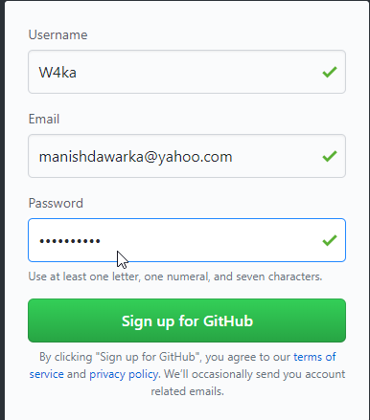

2)

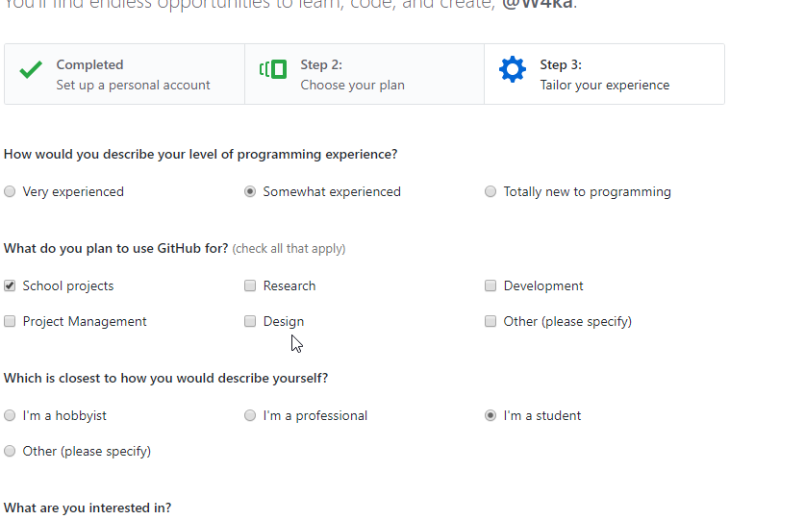

3)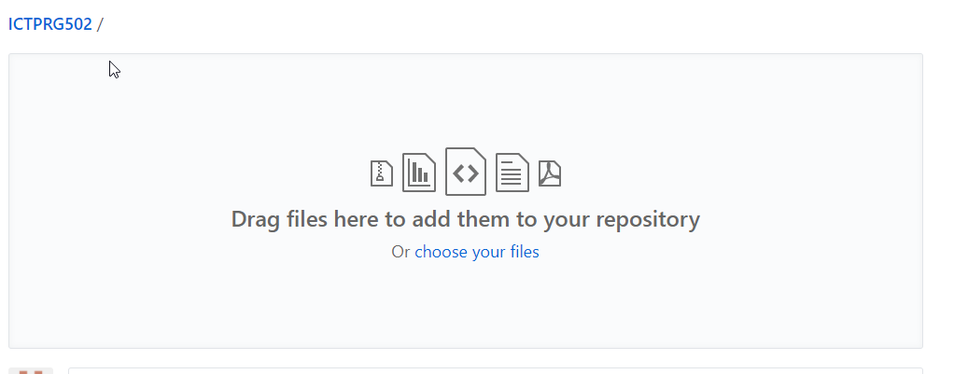

4)

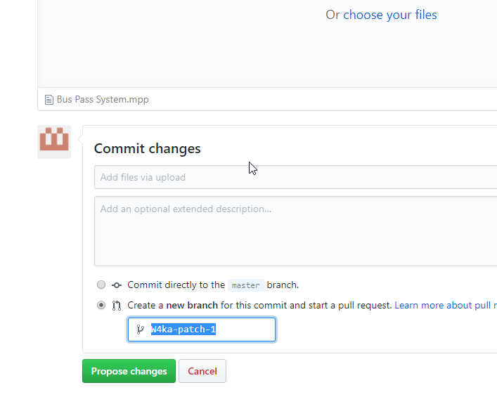

Collaboration software used is Google docs

